Lab 1.1.2b Lab Environment Setup – Hyper-V-1

1. Screenshot VM’s Local Server settings

1. Take a screenshot showing Windows Admin Center’s Overview information.

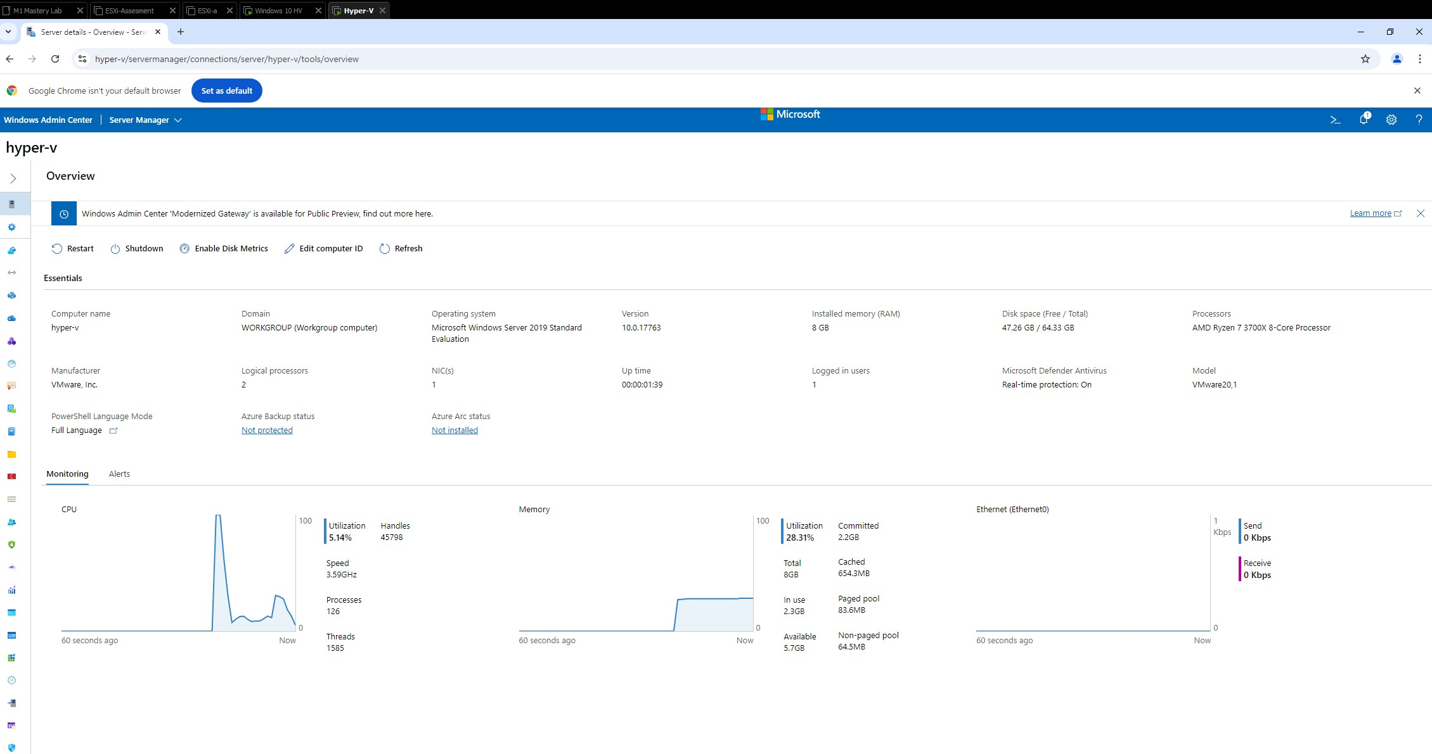

1. Open a Command Prompt, enter the command “ipconfig /all”, and take a

screenshot of the information.

